Chapter 5 Hands-on

Answer 1





Answer 2

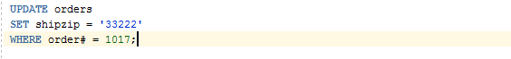



Answer 3





Answer 4



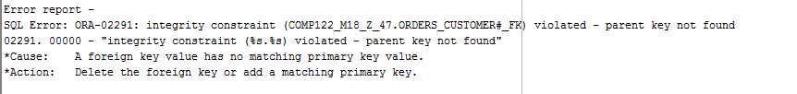

Reason for the error: there was no record stating the order number 1022 and customer number 2000 which are the primary key and foreign key and we are trying to assign that, which is not possible as it is violation.

Answer 5





Reason for the error: in order add the order value and the customer value in the order table we should either provide the orderdate or we should make the value for the orderdate a not null

Answer 6

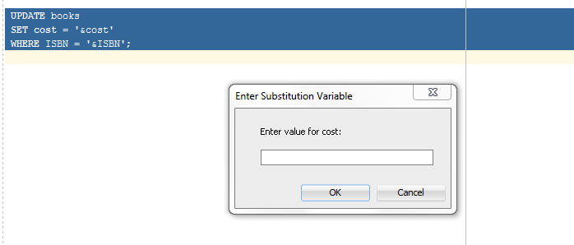

Answer 7

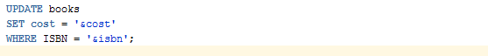



Answer 8



Answer 9





Answer 10



